**Experiment No: 1**

|  |
| --- |
| **Student Name and Roll Number:** Namit Kumar 19CSU185 |
| **Semester /Section:** V/FS-A-1 |
| **Link to Code:** |
| **Date:** 6th August 2021 |
| **Faculty Signature:** |
| **Marks:** |

|  |
| --- |
| **Objective(s):**  To familiarize the students to Linux interface. |
| **Outcome:**   * The students will understand commands used in Linux. |
| **Problem Statement:**  Implement the following things:   * Cygwin Installation * Basic Linux commands |
| **Background Study:**  Cygwin is a open source tool which provides that functionality of the Linux in windows Operating System. Cygwin is a large collection of GNU and Open Source tools which provide functionality similar to a [Linux distribution](https://en.wikipedia.org/wiki/Linux_distribution) on Windows. It is a DLL (cygwin1.dll) which provides substantial POSIX API functionality. |
| **Question Bank:**   1. **What is Linux?** 2. How will you List files from a directory? 3. How files in a directory can be removed? 4. How to find out a word in a file? 5. What are wildcards? |

**Student Work Area**

**Algorithm/Flowchart/Code/Sample Outputs**

**Q1.** Linux is a Unix-like, open source and community-developed operating system for computers, servers, mainframes, mobile devices and embedded devices. It is supported on almost every major computer platform including x86, ARM and SPARC, making it one of the most widely supported operating systems.

**Q2.** The ls command is used to list files or directories in Linux and other Unix-based operating systems.

**Q3.** Files can be removed using the rm command.

**Q4.** Grep is a Linux / Unix command-line tool used to search for a string of characters in a specified file. The text search pattern is called a regular expression. When it finds a match, it prints the line with the result.

**Q5.** A wildcard in Linux is a symbol or a set of symbols that stands in for other characters. It can be used to substitute for any other character or characters in a string. For example, you can use a wildcard to get a list of all files in a directory that begin with the letter O

**Screenshots**

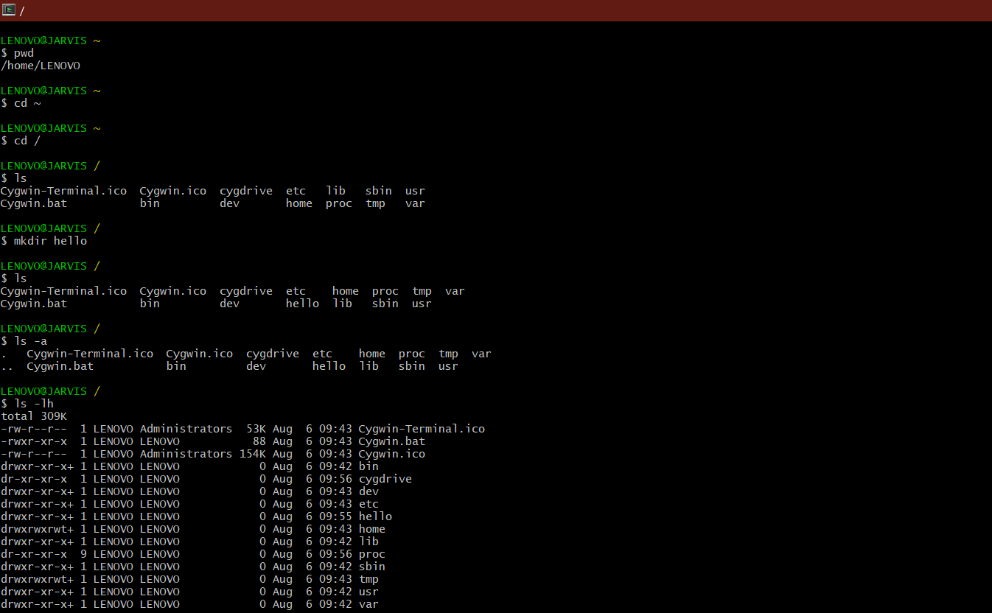

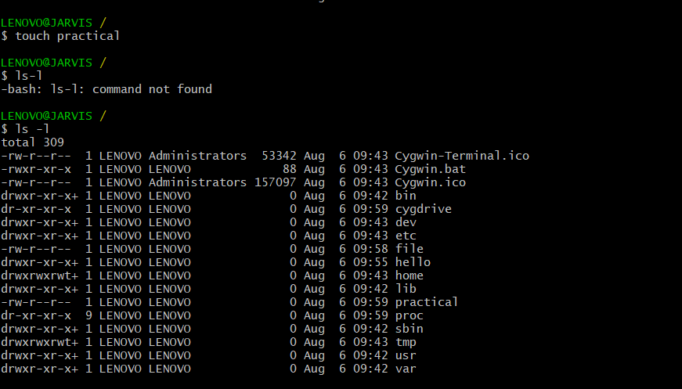

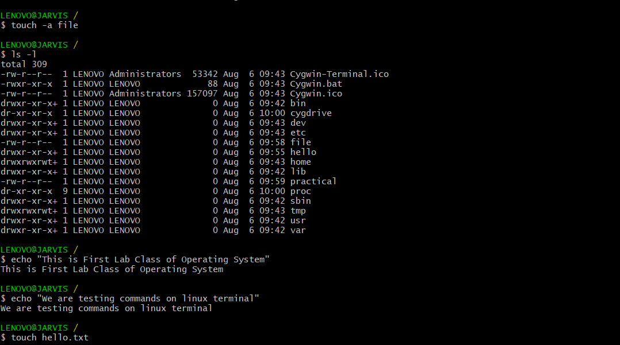

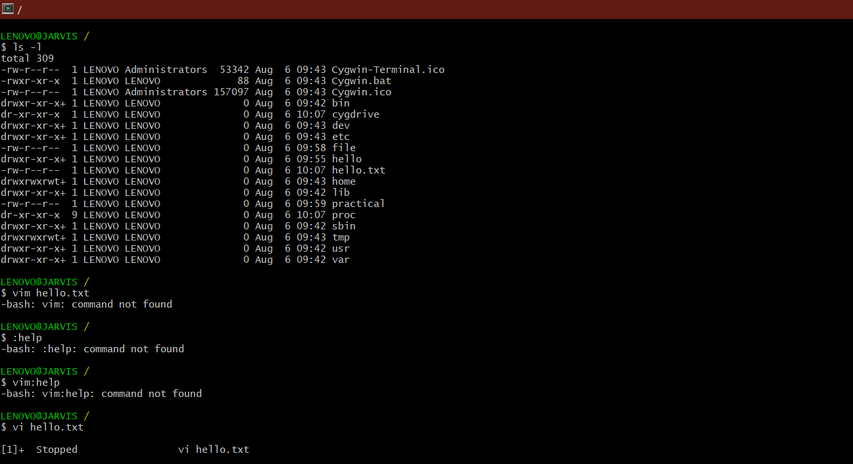

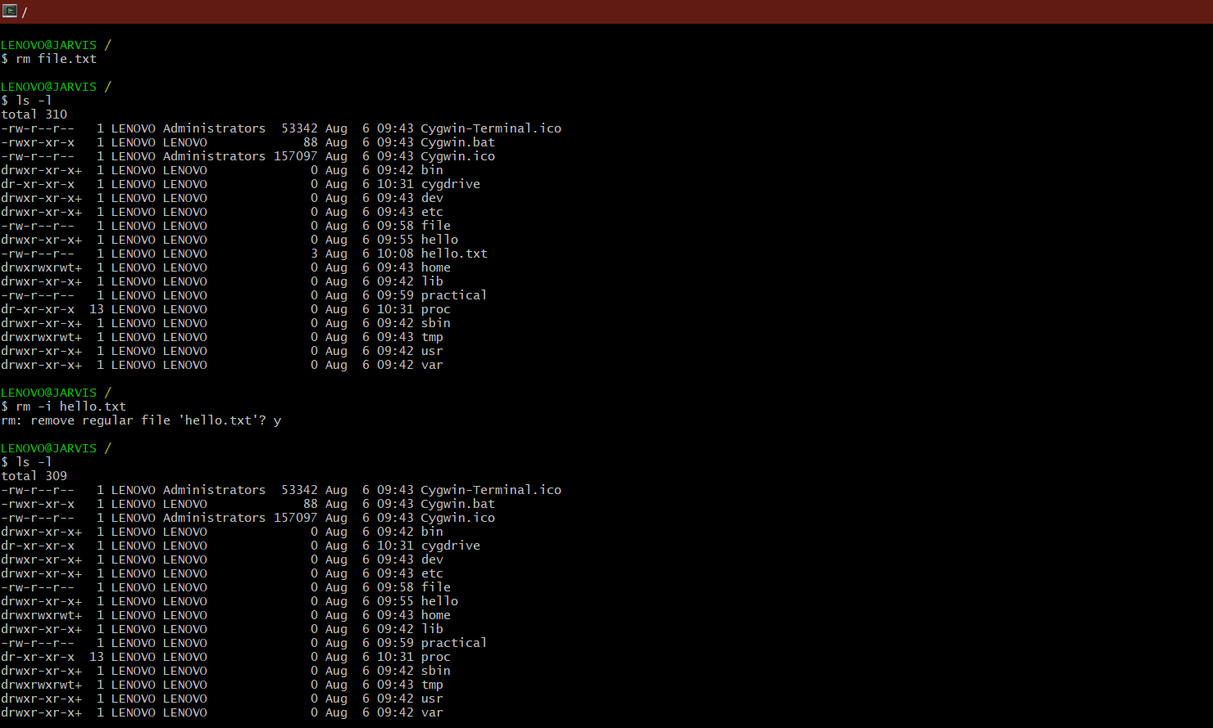

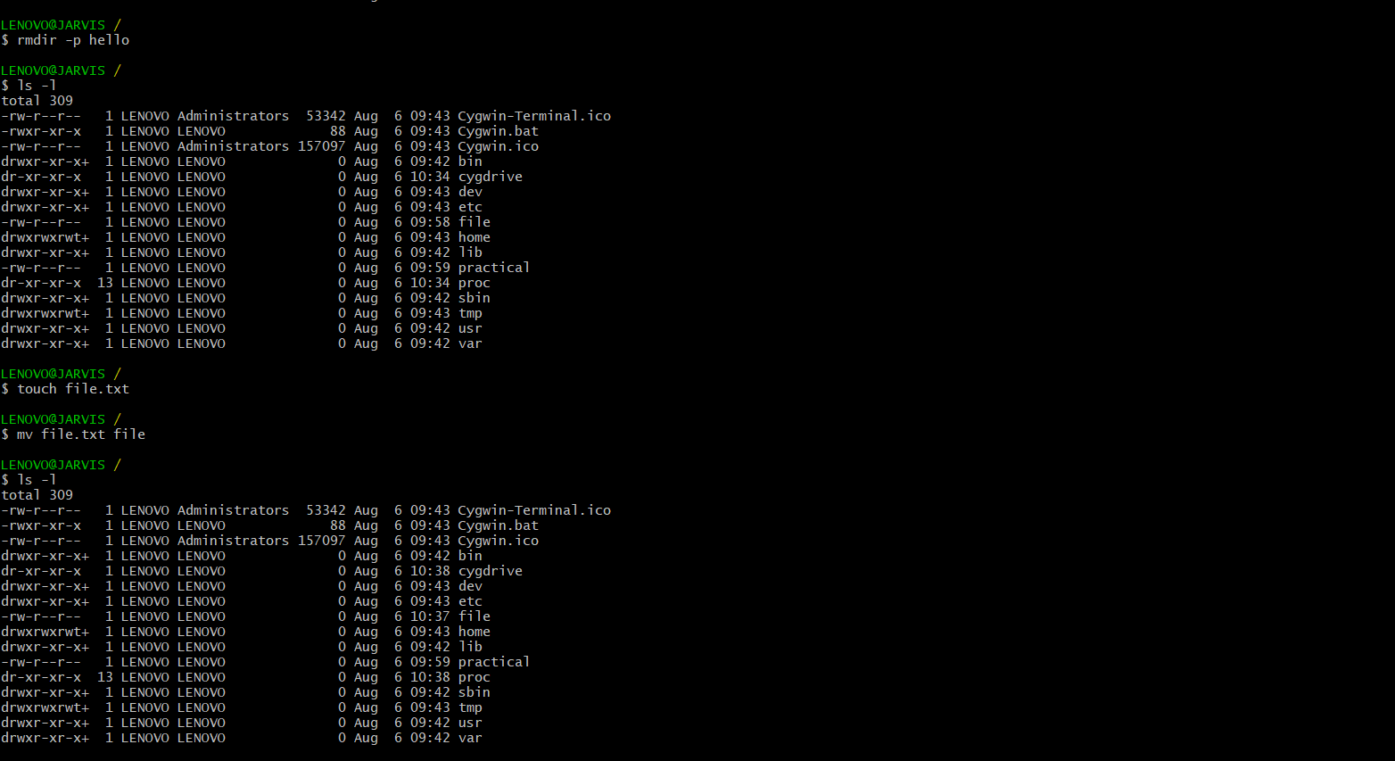

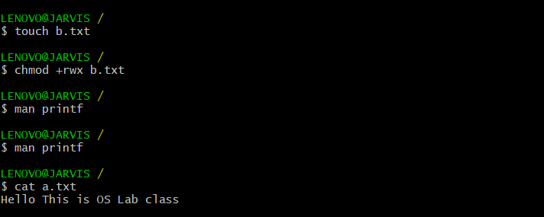

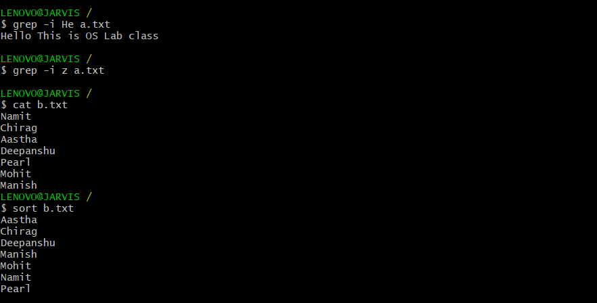

History Command to show all the commands used :-

